Solution Design

In the design of the new patient record system required for a Dental Practice, we had several design concepts. Out of the several concepts we, concluded through a process of elimination on the design route we should take with the software.

The basis of the software will run from a main menu we several sub menus taking the user to each desired category. Each sub menu will then lead to specific usage for that category, for example if the patient sub menu is selected they’re able to add/change personal information.

Each segment in this software will contain sensitive data, therefore security will remain an important factor, due to someone gaining unauthorized access could cause tremendous damage to everyone who attends the practices using this software.

Main Menu

The main menu will be the centre point of our software application. From the main menu the user will be able to decide what sub menu they want to see. These sub menus are as followed: Admin, Dentist, Patient. After the user has completed their business from one of the sub categories off the main menu, they will then be returned there which in turn makes the main menu the core root of the application as everything will link back to it.

Admin

The admin section of the software has several purposes for its implementation. In order to gain access to the admin section of the software, the user must first input the correct username and password for the admin account.

Firstly, in this section the user should be able to access several lists containing varying information. These lists are upcoming, appointments, previous visits and patient treatments. The admin should also be able to add/remove sections of information. This information are as follows: dentists, patients and the first-choice dentist. Finally, they should be able to alter the working days of the dentists working in the practice.

Due to the nature of the information being handled in this section of the software, keeping it secure is a priority due to if someone who is unauthorized gains access to the system then they can change highly sensitive data and remove people and information from the system.

Dentist

In the dentist section of the software, they will also be required to enter a correct password and username to gain access to this area of the programme. If the information is inputted incorrectly three times they are sent back to the main menu.

Once the user has correctly entered the information to gain access to this section they’re able to execute various tasks. Firstly, they’re able to change/add personal details.

They are also able to view upcoming and previous appointments of their patients. Furthermore, they should be able to view previous treatments for their patients and add treatments to a patient if necessary.

Ensuring that this section of the software has a working password and username login system is crucial as if not people can freely change the information in this segment which could be catastrophic for the practices using this software. Given the time frame, further development of security on this section would include dentists only being able to view the patients listed under their name and not everyone.

Patient

Following the pattern of the other sub menus in the software, the patient will also have a specific password and username which will allow them access to this segment. Here, the patient will be able to execute various tasks in the software and view information which has been held by the practice. Firstly, they should be able to add or change personal details. This will allow them to keep their data relevant in the system so that the practice knows their contact information. The patient should also be able to view lists of previous visits to the practice and a list of their previous treatments from the practice. Furthermore, the patient is also able to request for an appointment from this segment of the software. Given their information is up to date the dentist practice can then easily contact them confirming the appointment. Also, the patient is able to decide whether the admin can access their treatment list.

Login System

We created separate login systems for each segment of the users for the software. The dentist and patient login systems where deigned similarly in comparison to the admin login section which was designed differently due to the amount of accounts being required for dentist and patient compared to the admin. Firstly, the information for each account was saved on a separate line in an external text file. The patient and dentist accounts where saved to their own external text files to keep each type of account segregated from the other. The ‘PatientDetails.txt’ had a specific construction allowing the data to be read and/or wrote to. The file had 6 segments of data per line (for each patient). The file construction goes as follows: PatientID, Forename, Surname, Password, Address, Preferred Dentist. The login system scans the file taking the relevant information and comparing to the data being inputted to allow access. Secondly, the dentist external document follows a similar layout however, doesn’t require ‘Preferred Dentist’. When attempting to login into a dentist account the information inputted with be compared to the data held in the ‘DentistDetails.txt’.

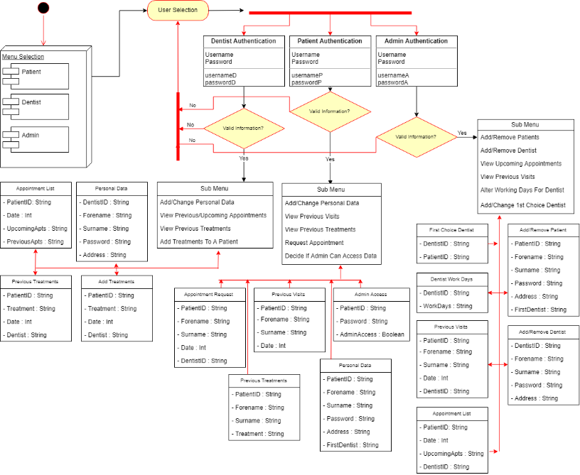To access the admin segment of the software the password and username have been hard-coded in as there is only 1 admin account. As a group decision we didn’t feel the need to have an external file dedicated to a single admin account. Considering the username and password is located in the code itself, if a change is required the data will have to be changed in the code itself.